Project Design Phase-II
Data Flow Diagram & User Stories

Date | 2 October 2026
Team ID | SWTID-2026-6255
Project Name | AI FAQ Assistant API
Maximum Marks | 4 Marks

Data Flow Diagram (DFD):
The Level-0 DFD below represents the main information flow of the AI FAQ Assistant API. It shows how a client sends a question or API request, how the API processes the request and retrieves relevant FAQ information from the knowledge base, and how the answer is returned. The diagram also shows the administrator flow for maintaining FAQ content and configuration.
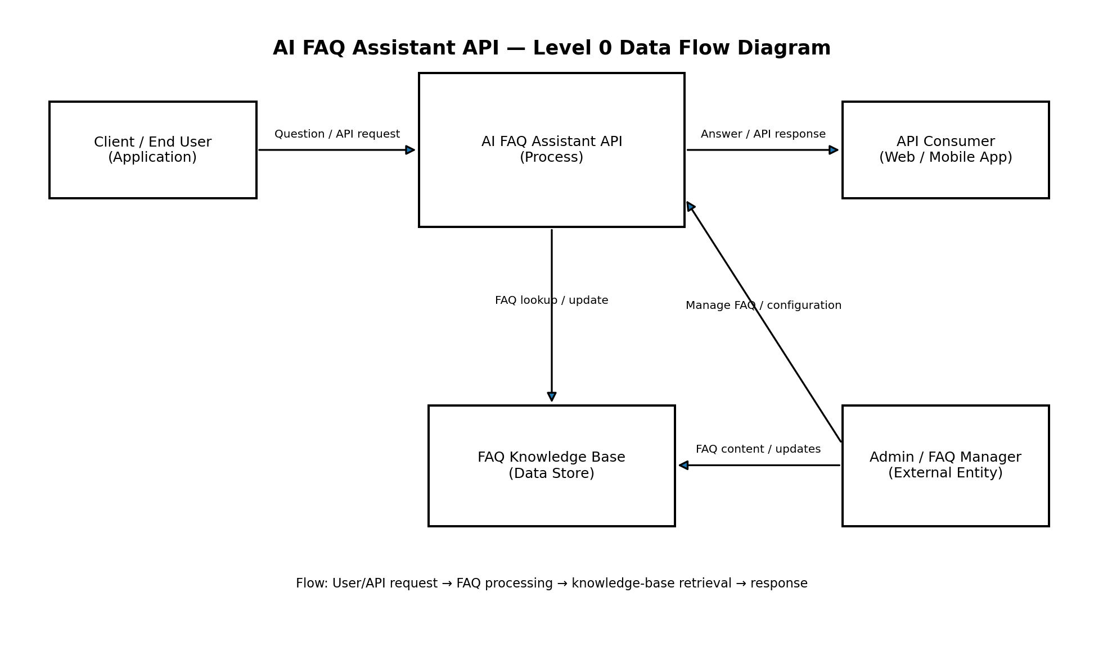
Example: DFD Level 0 (Industry Standard)



User Stories — AI FAQ Assistant API
The following user stories define the functional requirements for the AI FAQ Assistant API, including question answering, FAQ retrieval, fallback handling, API access, administration, and monitoring.
User Type | Functional Requirement (Epic) | User Story Number | User Story / Task | Acceptance criteria | Priority | Release
API Consumer | FAQ Query | USN-1 | As an API consumer, I can send a question to the AI FAQ Assistant API and receive an FAQ answer. | The API accepts a valid question and returns a relevant answer with a successful response. | High | Sprint-1
API Consumer | FAQ Query | USN-2 | As an API consumer, I can receive a clear response when the question matches an available FAQ. | The response contains the matched FAQ answer and a success status. | High | Sprint-1
API Consumer | FAQ Query | USN-3 | As an API consumer, I can submit questions in natural language without using an exact FAQ keyword. | The assistant identifies the relevant FAQ using semantic/natural-language matching. | High | Sprint-1
API Consumer | Fallback Handling | USN-4 | As an API consumer, I receive a safe fallback response when the knowledge base does not contain a reliable answer. | The API returns a predefined fallback message instead of inventing an answer. | High | Sprint-1
API Consumer | Validation & Errors | USN-5 | As an API consumer, I receive a meaningful error response when the request is missing or invalid. | Invalid input returns an appropriate error status and a clear error message. | High | Sprint-1
API Consumer | Authentication | USN-6 | As an API consumer, I can authenticate requests using the API access mechanism provided by the system. | Unauthenticated or invalid requests are rejected and valid credentials are accepted. | High | Sprint-2
API Consumer | API Response | USN-7 | As an API consumer, I receive a consistent response format that can be consumed by web or mobile applications. | Response fields and status codes follow the documented API contract. | Medium | Sprint-2
Administrator | FAQ Management | USN-8 | As an administrator, I can add a new FAQ question and answer to the knowledge base. | A valid FAQ entry can be added and becomes available for retrieval. | High | Sprint-2
Administrator | FAQ Management | USN-9 | As an administrator, I can update an existing FAQ answer when information changes. | The updated FAQ is stored and returned for subsequent matching queries. | High | Sprint-2
Administrator | FAQ Management | USN-10 | As an administrator, I can remove an outdated FAQ entry from the knowledge base. | The deleted FAQ is no longer returned by the assistant. | Medium | Sprint-2
Administrator | Monitoring | USN-11 | As an administrator, I can monitor API request and error information to identify issues. | Basic request and error information is recorded and can be reviewed. | Medium | Sprint-3
API Consumer | Documentation | USN-12 | As a developer, I can access API documentation to understand endpoints, request fields, and response formats. | Documentation describes available endpoints, parameters, authentication, and sample responses. | Medium | Sprint-3

Team Size: 4
Team Leader: Dinesh. M
Team Member: kalairajan. R
Team Member: Sharan K
Team Member: Sudharsan G
Project Team: Dinesh. M (Team Leader) | kalairajan. R | Sharan K | Sudharsan G

